ASSIGNMENT-9.4
2303A51852

Task 1: Auto-Generating Function Documentation in a Shared Codebase
Scenario
You have joined a development team where several utility functions are already implemented, but the code lacks proper documentation. New team members are struggling to understand how these functions should be used.
Task Description
You are given a Python script containing multiple functions without any docstrings.
Using an AI-assisted coding tool:
Ask the AI to automatically generate Google-style function docstrings for each function
Each docstring should include:
A brief description of the function Parameters with data types Return values
At least one example usage (if applicable)
Experiment with different prompting styles (zero-shot or context-based) to observe quality differences.
PROMPT:
You are a senior Python developer working in a collaborative development team.

The following Python script is part of a shared utility codebase, but it lacks proper documentation. New team members are struggling to understand how to use these functions.
Automatically generate well-structured Google-style docstrings for each function. Each docstring must include:
- A brief and clear description of the function
- Parameters with data types and explanation
- Return value with data type and explanation
- At least one example usage (if applicable)
- Proper formatting consistent with Google-style documentation
Ensure the documentation improves readability and usability of the codebase. Python Script:
def calculate_bonus(salary, percentage): return salary * (percentage / 100)
def count_large_numbers(numbers):
return len([n for n in numbers if n > 100]) def find_max(a, b):
if a > b:
return a return b
def calculate_average(numbers): total = sum(numbers)
return total / len(numbers) def is_even(number):
return number % 2 == 0
def convert_celsius_to_fahrenheit(celsius): return (celsius * 9/5) + 32
def greet_user(name):
return f"Hello, {name}!"

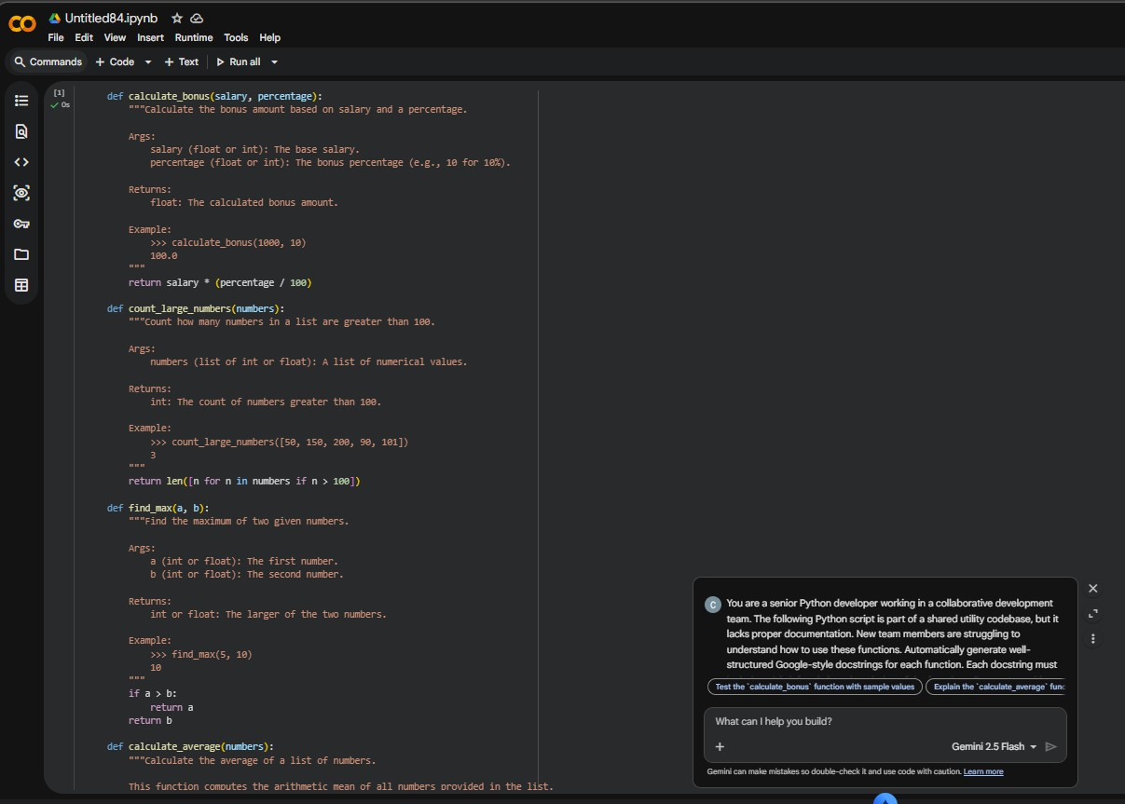

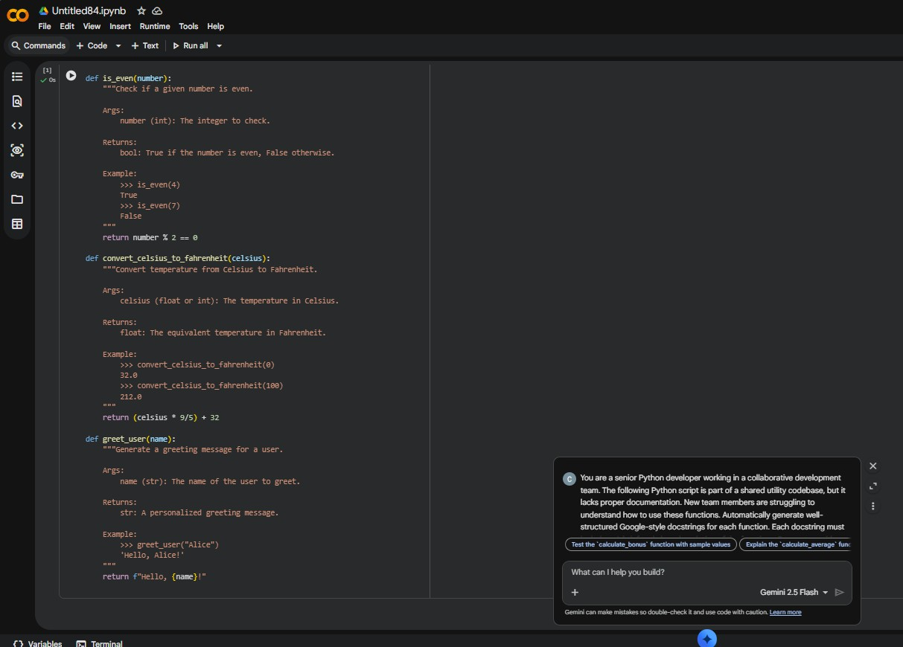
Task 2: Enhancing Readability Through AI-Generated Inline

Comments Scenario
A Python program contains complex logic that works correctly but is difficult to understand at first glance. Future maintainers may find it hard to debug or extend this code.
Task Description
You are provided with a Python script containing:
- Loops
- Conditional logic
- Algorithms (such as Fibonacci sequence, sorting, or searching) Use AI assistance to:
- Automatically insert inline comments only for complex or non- obvious logic
- Avoid commenting on trivial or self-explanatory syntax The goal is to improve clarity without cluttering the code.
PROMPT:
You are a senior Python developer reviewing a complex Python script.
The following program contains loops, conditional logic, and algorithm implementations such as Fibonacci sequence, sorting, and searching.
Insert inline comments only for complex or non-obvious logic. Avoid commenting on trivial or self-explanatory syntax.
Keep comments concise and meaningful. Do not change the original code logic.
Here is the script: def fibonacci(n):
if n <= 1: return n
a, b = 0, 1

for i in range(2, n + 1): a, b = b, a + b
return b

def bubble_sort(arr): n = len(arr)
for i in range(n):
for j in range(0, n - i - 1): if arr[j] > arr[j + 1]:
arr[j], arr[j + 1] = arr[j + 1], arr[j] return arr

def binary_search(arr, target): left = 0
right = len(arr) - 1 while left <= right:
mid = (left + right) // 2 if arr[mid] == target:
return mid
elif arr[mid] < target: left = mid + 1
else:
right = mid - 1 return -1

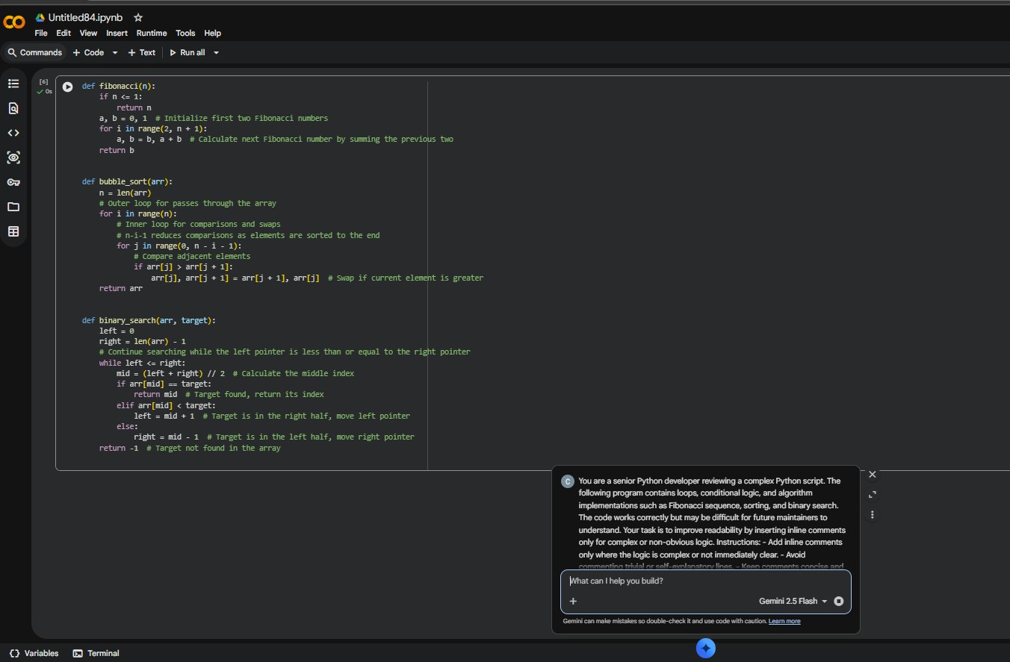
Task 3: Generating Module-Level Documentation for a Python Package
Scenario
Your team is preparing a Python module to be shared internally (or uploaded to a repository). Anyone opening the file should immediately understand its purpose and structure.
Task Description
Provide a complete Python module to an AI tool and instruct it to automatically generate a module-level docstring at the top of the file that includes:
- The purpose of the module
- Required libraries or dependencies
- A brief description of key functions and classes
- A short example of how the module can be used Focus on clarity and professional tone.
PROMPT:

You are a senior Python developer preparing a module for internal sharing and repository upload.
The following Python module needs a professional module-level docstring added at the very top of the file. Automatically generate a well-structured module-level docstring that includes:
- The overall purpose of the module
- Required libraries or dependencies (if any)
- A brief description of key functions and classes
- A short example showing how the module can be used
- Clear, professional tone and proper formatting Do not modify the existing code.
Only add the module-level docstring at the top of the file. Python Module:
import math
def calculate_area_of_circle(radius): return math.pi * radius ** 2
def calculate_factorial(n):
if n == 0 or n == 1:
return 1
return n * calculate_factorial(n - 1) class TemperatureConverter:
def celsius_to_fahrenheit(self, celsius): return (celsius * 9/5) + 32
def fahrenheit_to_celsius(self, fahrenheit): return (fahrenheit - 32) * 5/9
def is_prime(number):
if number <= 1:
return False
for i in range(2, int(math.sqrt(number)) + 1): if number % i == 0:
return False return True

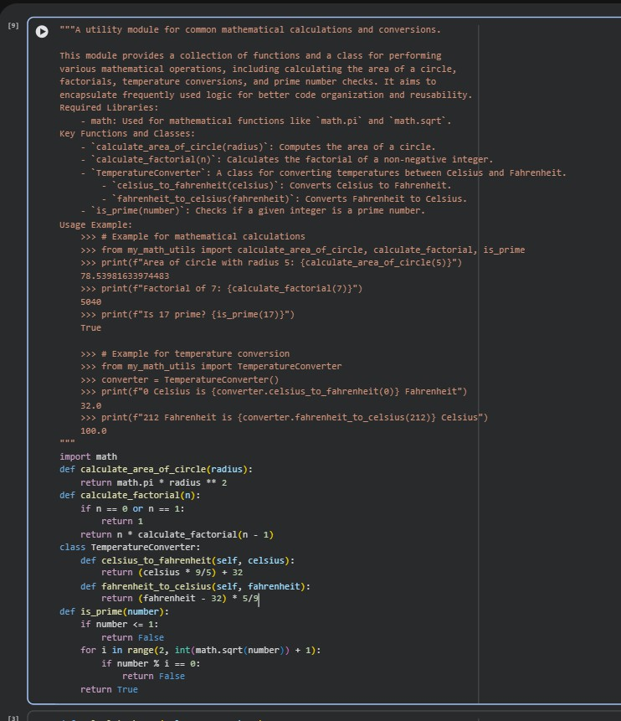
Task 4: Converting Developer Comments into Structured Docstrings Scenario
In a legacy project, developers have written long explanatory comments inside functions instead of proper docstrings. The team now wants to standardize documentation.
Task Description
You are given a Python script where functions contain detailed inline comments explaining their logic.
Use AI to:
- Automatically convert these comments into structured Google- style or NumPy-style docstrings
- Preserve the original meaning and intent of the comments
- Remove redundant inline comments after conversion

PROMPT:
You are a senior Python developer refactoring a legacy codebase.

The following Python script contains detailed explanatory inline comments inside functions instead of proper docstrings.
Your task is to:
- Convert the existing explanatory inline comments into structured Google-style docstrings.
- Preserve the original meaning and intent of the comments.
- Remove redundant inline comments after converting them into docstrings.
- Do NOT modify the actual logic of the code.
- Maintain professional formatting and consistency.

Ensure each docstring includes:
  - A brief description of the function
  - Args section with parameter names and data types
  - Returns section with return data type
  - Any important notes if necessary Here is the Python script:
def calculate_discount(price, discount_percentage):
# This function calculates the final price after applying a discount. # price is the original cost of the item.
# discount_percentage is the percentage of discount to apply.
# The function returns the price after subtracting the discount amount.

discount_amount = price * (discount_percentage / 100) final_price = price - discount_amount
return final_price
def find_largest_number(numbers):

# This function finds the largest number in a list.
# numbers is expected to be a list of numeric values.
# It loops through each element and keeps track of the maximum value found. # It returns the largest number in the list.

largest = numbers[0] for num in numbers: if num > largest:
largest = num return largest
def is_palindrome(text):
# This function checks whether the given text is a palindrome. # A palindrome reads the same forward and backward.
# It removes spaces and converts the text to lowercase before checking. # Returns True if the text is a palindrome, otherwise False.
cleaned = text.replace(" ", "").lower() return cleaned == cleaned[::-1]

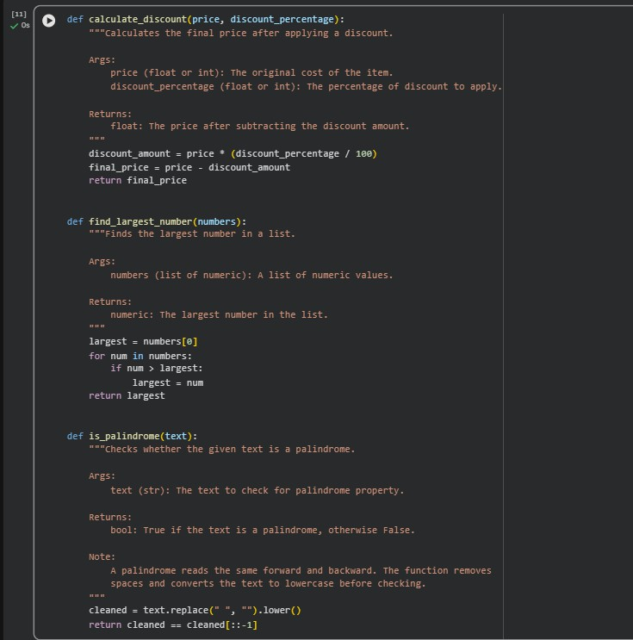
Task 5: Building a Mini Automatic Documentation Generator Scenario
Your team wants a simple internal tool that helps developers start documenting new Python files quickly, without writing documentation from scratch.
Task Description
Design a small Python utility that:
- Reads a given .py file
- Automatically detects:

- Functions
- Classes
- Inserts placeholder Google-style docstrings for each detected function or class
AI tools may be used to assist in generating or refining this utility.
Note: The goal is documentation scaffolding, not perfect documentation.
PROMPT:
You are a Python developer building a small internal tool for automatic documentation scaffolding.

Design a Python utility that:

- Reads a given .py file.
- Automatically detects:
  - Functions
  - Classes
- Inserts placeholder Google-style docstrings for each detected function or class.
- Does NOT aim to generate perfect documentation — only scaffolding placeholders.
- Preserves the original code logic and formatting as much as possible.
- Creates a new updated file instead of overwriting the original. Requirements:
  - Use standard Python libraries (such as ast if appropriate).
  - Ensure placeholders include:
    - Brief description section
    - Args section (for functions)
    - Returns section (for functions) Attributes/Methods section (for classes)

  - Maintain clean and professional formatting.
  - Add docstrings only if they are missing.
  - Do not modify existing docstrings.
Generate the complete working Python script for this utility.
